Discussion 4

How to Create Your Own Web Page In GitHub

#### **earning Outcome Addressed**

#### **5. Explain how to create a personal web page in GitHub**

Imagine I’m a new programmer who wants to create a personal web page using GitHub. You want to help me do so, but you don’t have time to do it with me, so you need to communicate how to do this without being right next to me.  
  
Develop a set of instructions in your own words for how I would create a personal GitHub page. Use the information you’ve gleaned from creating your own webpage in GitHub, the course videos, or even try to recreate another page on your own and walk us through step-by-step! You can use an article format, pictures, graphs, even a live video screencast!  
  
When you are done, post a link to your instructions on your LinkedIn and/or your Twitter account, and tag it with the tags #softwaredevelopment and #github!

**Submission Instructions:**

* Word count: 50-100
* You are encouraged to reply to your fellow learners to continue the conversation.

Sample

1. Open the github.com  
2. Create a Github account using Username, Email account and Password.  
3. Create a new repository like 'username.github.io' and keep other default values as it is and save it  
4. Go to the option add file and select upload file option. You will get a drag or drop file screen

// Vs Code  
1. Go to gitbash and type the command git clone your github path, The github folder will be cloned in the system.  
2. Open the cloned folder in vs code.  
3. Create a new file called index.html within the repository folder  
4. Add your image file to the folder.

// github

1. Drag the index.html file and image file and click commit changes  
2. Paste the username.github.io in a new browser and the web page can be viewed

Senthilkuppuswamy-RVS.github.io

Answer:

1. Open the github.com
2. Create a Github account using Username, Email account and Password.

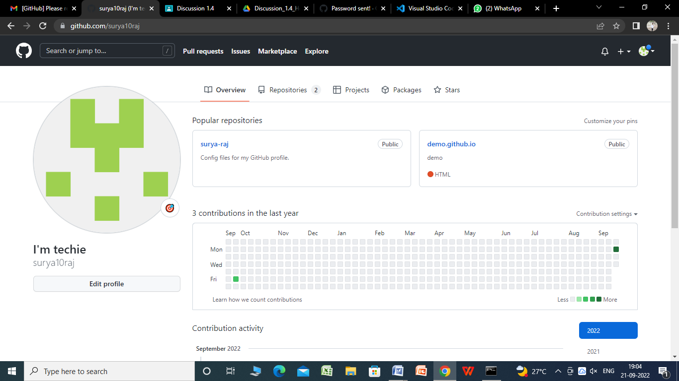

1. Create a new repository like 'username.github.io' and keep other default values as it is and save it

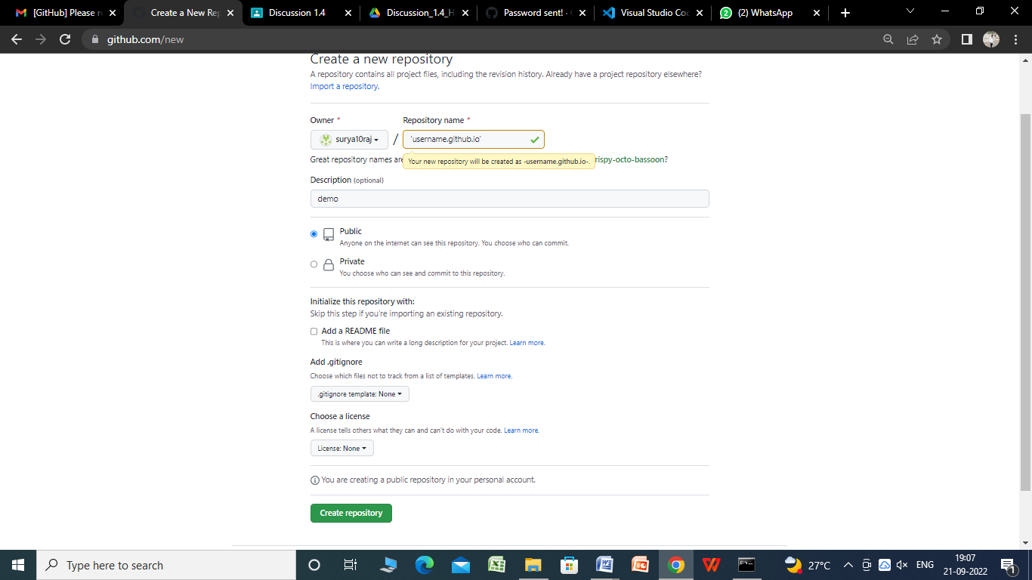

1. Go to the option add file and select upload file option. You will get a drag or drop file screen

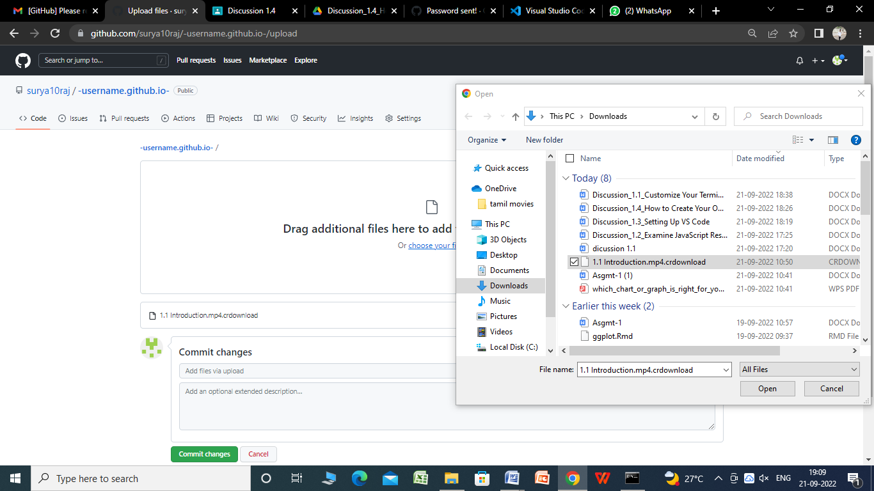

5.click commit changes to save the file.